**The Social Boundary: A Dynamic Framework for Human and Inter-species Sociability**

**Shreyash Srivastva**

Bachelor of Technology, Computer Science and Engineering,

Dr. A.P.J. Abdul Kalam Technical University, Lucknow, India.

[shreyash5183@gmail.com](mailto:shreyash5183@gmail.com) | <https://orcid.org/0000-0002-5524-8092>

**Abstract:**  
This paper introduces the concept of the Social Boundary, a dynamic limit governing sociability between humans, animals, and inter-species interactions. Unlike static models of social cognition, the Social Boundary adapts based on familiarity, context, and interaction frequency. We synthesize theories from psychology, sociology, and ethology, incorporating concepts like Social Penetration Theory, Dunbar’s Number, and Politeness Theory. Our proposed model suggests that social boundaries shrink as relationships develop, influencing communication styles and behavioral patterns. Furthermore, we highlight the phenomenon where significant familiarity can be built even within the first interaction, leading to an immediate reduction in social boundaries. Potential applications span AI-human interaction, urban social integration, and cross-cultural studies. By exploring these dimensions, this research provides a comprehensive understanding of how social boundaries evolve across different entities and environments.

**Research Questions Addressed:**

1. How do social boundaries dynamically evolve across human, animal, and AI interactions based on familiarity, context, and interaction frequency?
2. What factors contribute to the immediate reduction of social boundaries in first-time interactions, and how do they compare to gradual boundary shifts?

## ****1. Introduction****

Social interactions vary across individuals, cultures, and species. This paper explores a universal principle: the Social Boundary, which dictates the degree of sociability one maintains with others. The concept provides insights into the levels of formality, comfort, and behavioral adaptation in social exchanges. By examining the factors influencing the expansion and contraction of these boundaries, we gain a deeper understanding of social cognition and interpersonal dynamics.

### ****1.1 Defining the Social Boundary****

The Social Boundary refers to the dynamic threshold of formality and interaction comfort between entities. Initially large with strangers, it contracts with familiarity, facilitating informal communication and deeper trust. This threshold is influenced by numerous factors such as cultural norms, individual experiences, and contextual settings. The concept extends beyond human interactions and can be observed in animal behaviors and AI-driven communication systems, indicating a fundamental aspect of social evolution. Additionally, in many cases, individuals form strong bonds within a single interaction, rapidly decreasing the boundary size and allowing for immediate comfort and informality. This is why we often see that the choice of our words/vocabulary shifts as the other person has a change in their vocabulary and ideas to align with their ideas and build something in common to talk about.

### ****1.2 Theoretical Background****

We integrate existing psychological and sociological models, addressing their limitations:

* **Proxemics (Hall, 1966):** Proxemics studies the use of space in communication. While it explains physical distance and social comfort zones, it does not account for the gradual or rapid changes in social familiarity over time.
* **Social Penetration Theory (Altman & Taylor, 1973):** This theory posits that relationships develop through gradual self-disclosure. While it explains deepening relationships, it does not fully capture the fluctuating nature of social boundaries in various interactions, nor does it address the possibility of immediate familiarity formation.
* **Dunbar’s Number (Dunbar, 1992):** This theory suggests that humans have a cognitive limit to stable social relationships, approximately 150 individuals. However, it does not explain the dynamic shift in sociability boundaries with varying interaction contexts or initial deep connections.
* **Politeness Theory (Brown & Levinson, 1987):** This framework describes how language adapts based on social distance. It highlights the importance of formality but lacks a broader application beyond human interactions.

## ****2. Proposed Model: A Dynamic Social Boundary Framework****

We propose a mathematical model to quantify the social boundary:

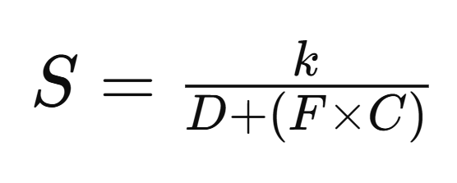

Where:

* **S (Social Boundary Size):** Represents the extent of formal or informal interaction limits.
* **D (Degree of Familiarity):** Indicates how well individuals or species know each other.
* **F (Frequency of Interaction):** Captures how often engagements occur, influencing comfort levels.
* **C (Context):** Encompasses factors like cultural settings, social environments, and the purpose of interaction.
* **K (Scaling Constant):** Adjusts for variability across different species and cultures.

### ****2.1 Evolution of Boundaries****

* **Initial Encounters:** During the first interaction, individuals typically maintain a **wide** social boundary, characterized by formality and cautious behavior. This applies to both human interactions and animal interactions, where initial engagements often involve observation and hesitation.
* **Immediate Familiarity Formation:** In some cases, individuals rapidly build rapport within the first conversation, leading to a sharp reduction in the boundary size. Shared interests, emotional resonance, or an engaging conversation can accelerate the comfort level, bypassing the typical gradual reduction.
* **Gradual Adaptation:** When familiarity does not form immediately, repeated engagements lead to a **shrinking boundary** where comfort and trust develop. Humans tend to shift from formal to casual speech, while animals display behavioral cues of trust.
* **Contextual Influence:** The setting of an interaction dictates the boundary's flexibility. In professional environments, boundaries shrink at a slower pace compared to casual social settings. Similarly, interactions across cultural differences may result in variable boundary shifts.
* **Adjustment of K Across Species:** Different species have varying social tendencies, affecting how quickly boundaries shrink. For instance, domesticated dogs rapidly lower their boundary upon sensing a friendly human, whereas wild animals, such as wolves, maintain a large boundary even with repeated exposure. K thus scales based on species-specific social behavior, experience with humans, and evolutionary predispositions toward sociability.

### ****2.2 Examples & Scenario Analysis****

#### ****Mathematical Model Examples****

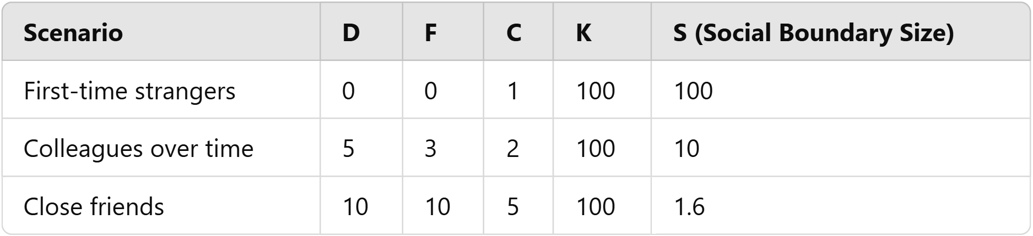

1. **Strangers Meeting for the First Time**
   * **D = 0**, **F = 0**, **C = 1** (neutral setting), **K = 100**

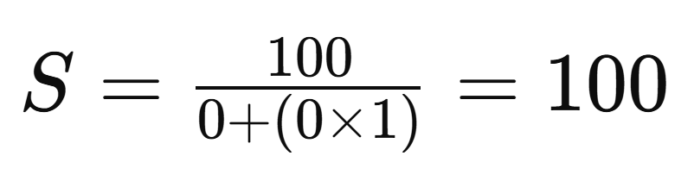

* + Interpretation: The social boundary is at its maximum, requiring formality.

1. **Colleagues Interacting Over Time**
   * **D = 5**, **F = 3**, **C = 2** (workplace setting), **K = 100**

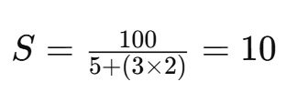

* + Interpretation: The boundary has decreased, allowing semi-casual interaction.

1. **Close Friends in an Informal Setting**
   * **D = 10**, **F = 10**, **C = 5** (relaxed setting), **K = 100**

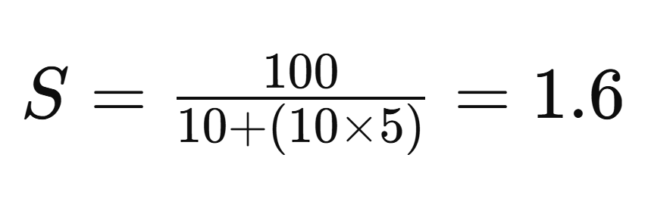

* + Interpretation: The boundary is almost negligible, allowing free interaction.

#### ****Human Interactions:****

* A diplomat meeting a foreign leader for the first time has a large social boundary, requiring extreme formality. In contrast, childhood friends have a small social boundary, allowing casual and open conversation.
* A student meeting a professor for the first time will maintain a high level of formality. However, after multiple classes and casual interactions, familiarity increases, reducing formality.

#### ****Cross-Species Interactions:****

* **Animal Sociability:** Wolves, primates, and other animals exhibit structured social boundaries within and across species. Their interactions demonstrate gradual trust-building similar to human relationships.
* **Human-Animal Interaction:** Domesticated animals, such as dogs and horses, initially approach humans with hesitation but develop stronger social bonds over time, reinforcing the concept of evolving social boundaries.
* Birds, like crows and parrots, display variable K values, adjusting sociability based on learned familiarity with humans.

#### ****AI & Social Robotics:****

* Social robots and AI-driven assistants could be programmed to adapt their interaction styles based on user engagement history, mimicking the natural shrinking of social boundaries.

## ****3. Applications & Implications****

### ****3.1 AI & Social Robotics****

AI-driven systems can implement dynamic social boundaries to improve user interactions. By recognizing patterns of familiarity, AI can shift from formal to informal engagement styles, increasing user trust and satisfaction.

* **Adaptive AI Behavior:** AI systems could be designed to recognize shifts in human communication and adjust responses accordingly, ensuring a more human-like interaction experience.
* **Ethical Considerations:** As AI learns from human interactions, ethical guidelines must be established to prevent overstepping boundaries too quickly or misinterpreting social cues.
* **Bias & Overfamiliarity**: Algorithms should be designed to prevent biases in boundary adaptation, ensuring cultural and personal sensitivity.

### ****3.2 Human Relationships & Cultural Studies****

This model can enhance cross-cultural communication by recognizing how different societies regulate social boundaries. Understanding these variations can lead to more effective diplomacy and social integration strategies.

* **Community Design:** Cities and workplaces can be structured to encourage natural social boundary adjustments, fostering inclusivity and community engagement.
* **Cultural Differences:** Societies with high collectivism may exhibit slower boundary shifts compared to individualistic cultures, affecting policy and workplace interactions.
* **Cross-Cultural Communication**: Recognizing varying social boundary dynamics can improve diplomacy and social integration.

### ****3.3 Urban Design & Social Cohesion****

Cities can be designed to encourage social boundary shifts that promote inclusivity. Public spaces that facilitate repeated interactions can enhance community bonding, improving social cohesion and reducing alienation.

* **Public Space Design**: Designing spaces that encourage repeated interactions can enhance community bonding and reduce social alienation.
* **Policy Development**: Social policies can be tailored to facilitate smooth integration among diverse populations.

### ****3.4 Cross-Species Communication & Wildlife Conservation****

* **Human-Wildlife Interactions:** Understanding interspecies boundary adaptation can improve conservation efforts and reduce conflicts in human-wildlife interaction zones.
* **Animal Sociability Research:** Different species exhibit unique boundary adaptation mechanisms, which can inform animal welfare policies and conservation strategies.

## ****4. Empirical Validation & Future Research****

### ****4.1 Experimental Design****

* **Surveys & Observational Studies:** Analyzing changes in communication styles, behavioral cues, and social comfort levels in human interactions.
* **Animal Behavior Studies:** Examining trust-building patterns in inter-species relationships over time.
* **AI-Human Interaction Analysis:** Testing adaptive AI models that modify their interaction based on user familiarity and engagement levels.

### ****4.2 Future Directions****

* **Neuro-scientific Approach:** Using neuro-imaging techniques to identify brain activity related to social boundary shifts.
* **Online & Digital Communication:** Investigating how anonymity and repeated interactions affect boundary formation in digital spaces.

**4.3 Future** **Research Questions To Be Addressed:**

* How can the Social Boundary framework be mathematically modeled to predict changes in sociability across different species and AI-driven interactions?
* What role do cultural norms and environmental contexts play in regulating the expansion and contraction of social boundaries?
* How can AI and social robotics integrate adaptive social boundaries to enhance human-computer interactions?
* What are the ethical considerations of AI-driven social boundary adaptation, and how can AI systems be designed to respect human comfort levels?
* How can understanding interspecies social boundaries aid in wildlife conservation and human-animal coexistence strategies?
* In what ways do online and digital communication alter traditional social boundary dynamics, and how do these changes compare to in-person interactions?

## ****5. Conclusion****

The Social Boundary model offers a dynamic perspective on sociability, applicable across human, animal, and AI interactions. By understanding how boundaries evolve, we can enhance interpersonal relationships, AI adaptability, and multicultural integration. The implications of this model span across technology, social sciences, and public policy, making it a significant contribution to understanding evolving human and inter-species interactions.

### ****References****

1. **Proxemics (Hall, 1966), <https://escholarship.org/uc/item/4774h1rm>**
2. **Social Penetration Theory (Altman & Taylor, 1973), <https://www.researchgate.net/publication/314626867_Social_Penetration_Theory>**
3. **Dunbar’s Number (Dunbar, 1992, <https://www.sciencedirect.com/science/article/abs/pii/004724849290081J?via%3Dihub>**
4. **Politeness Theory (Brown & Levinson, 1987),<https://psycnet.apa.org/record/1987-97641-000>**
5. **Easley, D., & Kleinberg, J. (2010). Networks, Crowds, and Markets: Reasoning About a Highly Connected World.**
6. **Zhou, X. et al. (2021). AI-Driven Interpersonal Communication: Enhancing Digital Interactions Through Adaptive Models.**